Swift at

Participant Activity Packet

Participant Name:
Session Date(s):
User Role:
SWIS Facilitator(s):
Facilitator Contact Information:

Section A Notes:

Section B Notes:
Section C: Roles & Access Levels
Reflection on Data Integrity and Confidentiality

- How will data integrity be maintained and prioritized in staff communications?

- How will we maintain the confidentiality of SWIS data while also giving the right people access to the right information for decision-making?

Section D: SWIS Account Set-Up (Tools)
Exploration in the Facilitator Training Account
Facilitator Training Account. Username: facilitator Password:
Settings. Together we’ll explore functionality in the School Settings as if you were an Admin user and look at Account Settings that all users will manage. Each person will identify which access level can complete the task in a real/live account. Then one person will be assigned to complete the task.
Hint: School Settings are school-wide and Account Settings are user-specific.

# | Task | Who Has Access?
1 | The school changed their grade levels. Update the account to change the grades to either K-12 or your school’s grade range. | - SWIS Admin  - SWIS Data Entry  - Both Admin and D.E.  - All access levels except REO  - All access levels
2 | Due to missed school days during the winter (already recorded in SWIS), the school is extending the school year by 3 student contact days. Update the account to reflect the added days (pick any month you want). | - SWIS Admin  - SWIS Data Entry  - Both Admin and D.E.  - All access levels except REO  - All access levels
3 | The school-wide team has determined the following updates are appropriate. Update the account.  - Both a primary and up to two additional behaviors will be recorded (as appropriate)  - Up to 3 Actions Taken can be indicated on the referral  - 504 information will not be recorded in SWIS, but IEP information will be  - District ID’s for both staff and students are required | - SWIS Admin  - SWIS Data Entry  - Both Admin and D.E.  - All access levels except REO  - All access levels
4 | The data entry staff prefers to view students by first name then last name. The data analysts prefer last name then first.  - Can we have it both ways?  - Can one user set this up for another user? | - SWIS Admin  - SWIS Data Entry  - Both Admin and D.E.  - All access levels except REO  - All access levels
5 | The school-wide team has determined that they want to track types of Harassment within SWIS.  Enable harassment sub-types. (Keep default categories) | - SWIS Admin  - SWIS Data Entry  - Both Admin and D.E.  - All access levels except REO  - All access levels
6 | Update SWIS to show that the school year starts in August. | - SWIS Admin  - SWIS Data Entry  - Both Admin and D.E.  - All access levels except REO  - All access levels

7 | You decide that you prefer both referral entry and reports to default to Major referrals. Update your settings. | - SWIS Admin  - SWIS Data Entry  - Both Admin and D.E.  - All access levels except REO  - All access levels
Person Management. Next we’ll explore Person Management as if you were an Admin or Data Entry user. We will discuss the procedures then someone will be assigned to complete the task. Make up any information that is not provided.

# | Task
1 | Codi Franks is a student in the 6th grade. His district ID is 10744 and his enrollment records indicate his race and ethnicity as White, Not Hispanic Latino. Codi has a 504.
2 | Janice Bowman is a teacher at the school. Her name recently changed to Janice Mulligan. What is the most efficient way to update SWIS?
3 | Danny Kay received a referral. This is his first referral since coming to the school. Danny’s full name is: Daniel Kay  Danny’s District ID is: 60215  Ethnicity/Race: Hispanic/Latino, America Indian  Danny has an IEP under the category of “Orthopedic Impairment”
5 | Sam Neeten moved to another school in the district. The same thing happened last year but Sam ended up re-enrolling.  What should you do to update SWIS?
6 | (Everyone) Enter three new students and two new staff members.  *Make up their information.
7 | John Candy and Samual Fullerton have graduated from the school. Update the status of both students.
Data Integrity. Next we’ll explore Data Integrity as if you were an Admin or Data Entry user. We will discuss the procedures then someone will be assigned to complete the task. Make up any information that is not provided.

# | Task
1 | When checking Data Integrity for the school’s account, indicate that SWIS should ignore errors in all categories prior to September 1st of last year. | - ​
2 | Open the Data Integrity tool.  Are there errors related to Staff and/or Student records?  If so fix at least three of these errors. | - ​

Section E: Referral Data Entry & Review
Entering Referral Data into SWIS
Facilitator Training Account:
Username: facilitator Password:
Data Entry. Each person will enter the referrals on the following pages into SWIS. You will be creating duplicate records but that’s okay (we can practice fixing data integrity errors later).
Try to go slowly through the first one or two and then speed up. A highly fluent data entry user can enter a basic referral in under 40 seconds.

Referral A
- Referral B
- Referral C1 (Use the Save & Copy button instead of the Save button)

Referral C2
- Referral D

Discuss as a group
- How will we ensure that data stay accurate and up-to-date?

- What procedures are needed to support staff to consistently respond to and document problem behavior?

- If referral data are incomplete, inaccurate, or unprofessional (e.g., emotionally inflated) who will follow-up with the reporting staff member?

Minor Referral  Staff Managed | Major Referral  Administrator Managed | Entered into SWIS: Yes No  Referral ID:
Student:  Sara Milton | Grade:  K 1 2 3 4 5 | Referring Staff:  Joy Songbird
Date:  2 days ago |  | Time:  1:10 PM
Location: Classroom Hallway Playground Cafeteria Gym Commons Restroom Art Room Library Music Room Computer Lab Office Assembly/Field Trip Bus Bus Loading Zone Off-Campus Parking Lot
Minor Problem Behavior: Disrespect Defiance Disruption Physical Contact/Physical Aggression Tardy Inappropriate Language Property Misuse Dress Code Violation Technology Violation
Major Problem Behavior: Defiance/Non-Compliance Physical Aggression Disruption Disrespect Inappropriate Language Tardy Skip Class Bullying Fighting Inappropriate Location Truancy Forgery/Theft/Plagiarism Lying/Cheating Dress Code Violation Inappropriate Display of Affection
Gang Affiliation Display Bomb Threat/False Alarm Arson
Use/Possession of (circle one): Tobacco Drugs *Weapons Combustibles Alcohol
*If a weapon was involved, please note the weapon type:
Harassment (circle type): Gender Ethnicity Sexual Race Religion Disability Physical Characteristics
Perceived Motivation: Obtain Peer Attention Obtain Adult Attention Obtain Item/Activity Avoid Peer(s) Avoid Adult Avoid Task/Activity
Others Involved: None Peers Teacher Staff Substitute Other Unknown
Action Taken: Alternative Placement Time Out/Detention Conference with Student Loss of Privilege Time in Office Individualized Instruction Additional Attendance/Saturday School Bus Suspension Restitution Community Service Other Action Taken Parent Contact (form: )
In-School Suspension ( ½ day increments): . days Out-of-School Suspension: ( ½ day increments): . days Expulsion
Notes:

Minor Referral  Staff Managed | Major Referral  Administrator Managed | Entered into SWIS: Yes No  Referral ID:
Student:  Anya Laramie | Grade:  6 7 8 | Referring Staff:  Thomas Martin
Date:  Today |  | Time:  2:45 PM
Location: Classroom Hallway Playground Cafeteria Gym Commons Restroom Art Room Library Music Room Computer Lab Office Assembly/Field Trip Bus Bus Loading Zone Off-Campus Parking Lot
Minor Problem Behavior: Disrespect Defiance Disruption Physical Contact/Physical Aggression Tardy Inappropriate Language Property Misuse Dress Code Violation Technology Violation
Major Problem Behavior: Defiance/Non-Compliance Physical Aggression Disruption Disrespect Inappropriate Language Tardy Skip Class Bullying Fighting Inappropriate Location Truancy Forgery/Theft/Plagiarism Lying/Cheating Dress Code Violation Inappropriate Display of Affection
Gang Affiliation Display Bomb Threat/False Alarm Arson
Use/Possession of (circle one): Tobacco Drugs *Weapons Combustibles Alcohol
*If a weapon was involved, please note the weapon type:
Harassment (circle type): Gender Ethnicity Sexual Race Religion Disability Physical Characteristics
Perceived Motivation: Obtain Peer Attention Obtain Adult Attention Obtain Item/Activity Avoid Peer(s) Avoid Adult Avoid Task/Activity
Others Involved: None Peers Teacher Staff Substitute Other Unknown
Action Taken: Alternative Placement Time Out/Detention Conference with Student Loss of Privilege Time in Office Individualized Instruction Additional Attendance/Saturday School Bus Suspension
Restitution Community Service Other Action Taken Parent Contact (form: _phone call ) In-School Suspension ( ½ day increments): . days Out-of-School Suspension: ( ½ day increments): . days Expulsion
Notes: Anya mocked another student’s religion by using the photographs in non-fiction, religious library books to
ask if the student was related to the “weird” and “strange” people in the pictures. She repeatedly asked the student what animal he worshiped.

Minor Referral  Staff Managed | Major Referral  Administrator Managed | Entered into SWIS: Yes No  Referral ID:
Student:  Winston Weller | Grade:  K 1 2 3 4 5 | Referring Staff:  Kathy Holland
Date:  Yesterday |  | Time:  11:30 AM
Location: Classroom Hallway Playground Cafeteria Gym Commons Restroom Art Room Library Music Room Computer Lab Office Assembly/Field Trip Bus Bus Loading Zone Off-Campus Parking Lot
Minor Problem Behavior: Disrespect Defiance Disruption Physical Contact/Physical Aggression Tardy Inappropriate Language Property Misuse Dress Code Violation Technology Violation
Major Problem Behavior: Defiance/Non-Compliance Physical Aggression Disruption Disrespect
Inappropriate Language Tardy Skip Class Bullying Fighting Inappropriate Location Truancy Forgery/Theft/Plagiarism Lying/Cheating Dress Code Violation Inappropriate Display of Affection
Gang Affiliation Display Bomb Threat/False Alarm Arson
Use/Possession of (circle one): Tobacco Drugs *Weapons Combustibles Alcohol
*If a weapon was involved, please note the weapon type:
Harassment (circle type): Gender Ethnicity Sexual Race Religion Disability Physical Characteristics
Perceived Motivation: Obtain Peer Attention Obtain Adult Attention Obtain Item/Activity Avoid Peer(s) Avoid Adult Avoid Task/Activity
Others Involved: None Peers Teacher Staff Substitute Other Unknown
Action Taken: Alternative Placement Time Out/Detention Conference with Student Loss of Privilege Time in Office Individualized Instruction Additional Attendance/Saturday School Bus Suspension Restitution Community Service Other Action Taken Parent Contact (form: _conference )
In-School Suspension ( ½ day increments): . days Out-of-School Suspension: ( ½ day increments): . days Expulsion
Notes: _Winston and another student got into an argument during a basketball game on the playground. The
disagreed about a foul and became physically aggressive. Both students pushed, shoved, threw the ball at the other person, and used inappropriate language. Both students will lose recess privileges the for 5 days.

Minor Referral  Staff Managed | Major Referral  Administrator Managed | Entered into SWIS: Yes No  Referral ID:
Student:  Justin Burbanks | Grade:  K 1 2 3 4 5 | Referring Staff:  Kathy Holland
Date:  Yesterday |  | Time:  11:30 AM
Location: Classroom Hallway Playground Cafeteria Gym Commons Restroom Art Room Library Music Room Computer Lab Office Assembly/Field Trip Bus Bus Loading Zone Off-Campus Parking Lot
Minor Problem Behavior: Disrespect Defiance Disruption Physical Contact/Physical Aggression Tardy Inappropriate Language Property Misuse Dress Code Violation Technology Violation
Major Problem Behavior: Defiance/Non-Compliance Physical Aggression Disruption Disrespect
Inappropriate Language Tardy Skip Class Bullying Fighting Inappropriate Location Truancy Forgery/Theft/Plagiarism Lying/Cheating Dress Code Violation Inappropriate Display of Affection
Gang Affiliation Display Bomb Threat/False Alarm Arson
Use/Possession of (circle one): Tobacco Drugs *Weapons Combustibles Alcohol
*If a weapon was involved, please note the weapon type:
Harassment (circle type): Gender Ethnicity Sexual Race Religion Disability Physical Characteristics
Perceived Motivation: Obtain Peer Attention Obtain Adult Attention Obtain Item/Activity Avoid Peer(s) Avoid Adult Avoid Task/Activity
Others Involved: None Peers Teacher Staff Substitute Other Unknown
Action Taken: Alternative Placement Time Out/Detention Conference with Student Loss of Privilege Time in Office Individualized Instruction Additional Attendance/Saturday School Bus Suspension Restitution Community Service Other Action Taken Parent Contact (form: _conference )
In-School Suspension ( ½ day increments): . days Out-of-School Suspension: ( ½ day increments): . days Expulsion
Notes: _Justin and another student got into an argument during a basketball game on the playground. The
disagreed about a foul and became physically aggressive. Both students pushed, shoved, threw the ball at the other person, and used inappropriate language. Both students will lose recess privileges the for 5 days.

Minor Referral  Staff Managed | Major Referral  Administrator Managed | Entered into SWIS: Yes No  Referral ID:
Student:  Keri Floyd | Grade:  9 10 11 12 | Referring Staff:  Kathy Holland
Date:  4 days ago |  | Time:  8:50 AM
Location: Classroom Hallway Playground Cafeteria Gym Commons Restroom Art Room Library Music Room Computer Lab Office Assembly/Field Trip Bus Bus Loading Zone Off-Campus Parking Lot Locker Room
Minor Problem Behavior: Disrespect Defiance Disruption Physical Contact/Physical Aggression Tardy Inappropriate Language Property Misuse Dress Code Violation Technology Violation
Major Problem Behavior: Defiance/Non-Compliance Physical Aggression Disruption Disrespect Inappropriate Language Tardy Skip Class Bullying Fighting Inappropriate Location Truancy Forgery/Theft/Plagiarism Lying/Cheating Dress Code Violation Inappropriate Display of Affection
Gang Affiliation Display Bomb Threat/False Alarm Arson
Use/Possession of (circle one): Tobacco Drugs *Weapons Combustibles Alcohol
*If a weapon was involved, please note the weapon type:
Harassment (circle type): Gender Ethnicity Sexual Race Religion Disability Physical Characteristics
Perceived Motivation: Obtain Peer Attention Obtain Adult Attention Obtain Item/Activity Avoid Peer(s) Avoid Adult Avoid Task/Activity
Others Involved: None Peers Teacher Staff Substitute Other Unknown
Action Taken: Alternative Placement Time Out/Detention Conference with Student Loss of Privilege Time in Office Individualized Instruction Additional Attendance/Saturday School Bus Suspension Restitution Community Service Other Action Taken Parent Contact (form: _phone call )
In-School Suspension ( ½ day increments): . days Out-of-School Suspension: ( ½ day increments): . days Expulsion
Notes: _Keri was skipping 1st period and was caught in the locker room with cigarettes and a lighter.

Section F: SWIS Basic Reporting & Analysis
Exploring SWIS Reports
In the SWIS Demo Account, explore the SWIS Core Reports and respond to each item below.
- Generate the Average Referrals Per Day Per Month report. For the current* school year, describe the levels, trends, and peaks for Major Referrals.
*Use previous year if there are fewer than 2 months with data.

School Year
Trends
Peaks
Levels

- What were the most recently referred problem behaviors (All Referrals)?

You will use this as a “red flag” in the next activity (Drill Down 1).

Date Range
Behavior(s)

- What campus location have staff recently observed and reported problem behaviors (All Referrals)? You will use this as a “red flag” in the next activity (Drill Down 2).

Date Range
Location(s)

- Identify how many students have received 2-5 referrals and how many have received six or more referrals (All Referrals) in the last three months.
2-5 Referrals: _________________ students 6+ Referrals students

- Which grade level(s) have recently been referred most often for problem behavior in the last three months?

Date Range: __________________________ Grade Level: _________

Section G
SWIS Drill Down

- Drill Down 1 - Conduct a drill-down task in the SWIS Demo Account.
Red flag item is identified by analyzing Core Reports (most common), Additional Reports, Student Dashboard, or SWIS Dashboard (less common/less preferred). Reminder: Add filters one at a time.
Red flag item: | Who? What? When? Where? |  |  |  |  |  | Date Range:
Drill-Down Filter(s): |  | Who? What? When? Where? Why?
Drill-Down Filter(s): |  | Who? What? When? Where? Why?
Drill-Down Filter(s): |  | Who? What? When? Where? Why?
Drill-Down Filter: |  | Who? What? When? Where? Why?
Referral  Summary: |  | Number of referrals included: ________  Number of students involved: ________ |  |  | Is the problem best addressed through systems or with individual students:  Systems (10+) Students ( <10)
Precise Problem Statement:
Goal:
Solution Development
Solution Components |  | What are the action steps? | Who is Responsible? | By When? |  | How will fidelity be measured? |  | Notes/Updates
Prevention
Teaching
Recognition
Extinction
Corrective Consequence
 |  | What data will we  look at? | Who is responsible for gathering data? | When/How often will data be gathered? |  | Where will data be shared? |  | Who will see the data?
Data Collection
Section G
Equity and Drill Down

Red flag item is identified by analyzing Core Reports (most common), Additional Reports, Student Dashboard, or SWIS Dashboard (less common/less preferred). Reminder: Add filters one at a time.
Identified Subgroup | Who? What? When? Where? |  |  |  |  |  | Date Range:
Drill-Down Filter(s): |  | Who? What? When? Where? Why?
Drill-Down Filter(s): |  | Who? What? When? Where? Why?
Drill-Down Filter(s): |  | Who? What? When? Where? Why?
Drill-Down Filter: |  | Who? What? When? Where? Why?
Referral  Summary: |  | Number of referrals included: ________  Number of students involved: ________ |  |  | Is the problem best addressed through systems or with individual students:  Systems (10+) Students (<10)
Precise Problem Statement:
Goal:
Solution Development
Solution Components |  | What are the action steps? | Who is Responsible? | By When? |  | How will fidelity be measured? |  | Notes/Updates
Prevention
Teaching
Recognition
Extinction
Corrective Consequence
 |  | What data will we  look at? | Who is responsible for gathering the data? | When/How often will data be gathered? |  | Where will data be shared? |  | Who will see the data?
Data Collection

Wrapping Up
Swift at SWIS Exit Activity
Carefully remove both the exit activity and following evaluation from your packet. Complete each item with as much or little detail.

Name:
Stars: What was the most helpful activity during this training?

- We accomplished our objectives
- This was a good use of my time
- I am comfortable taking on this role

Stairs: What more do I need to feel confident in my role as a SWIS (fill in your role) user?

Which of the following would be most helpful as a next step (check at least one)?
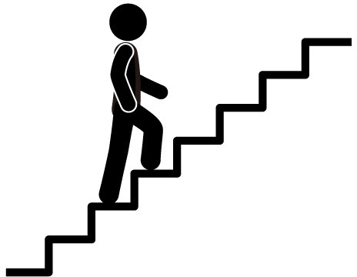
  - Check with me in about 1 week please
  - Feedback on my first drill down
  - Feedback on my first data summary
  - Help with my first drill down
  - Help with my first data summary
  - Other idea:

PBIS Tier I Team SWIS Summary Update
Date: 10/19/2017
Data Analyst: Katie Von Datageek

Every month the PBIS team analyzes our referral data and selects one or two problems to address. We look for patterns in context, behavior, and perceived motivation to prioritize and build solutions. Thank you so much for your consistency in following the behavior protocols and submitting referrals.
Your data help everyone to be more efficient and effective!
Summary (Where, What, When)
Averages: Our Avg Referrals for September was 5.5 which is near the 75th percentile nationally
Locations: Classroom (36%), Common (15%), Playground (14%), Hallway (14%),
Café (12%)
Behaviors: Language (22%), Defiance (21%), Harassment (19%)
Date/Time: Small increase on Fridays, peaks from 9am-9:30am and 1pm-2pm
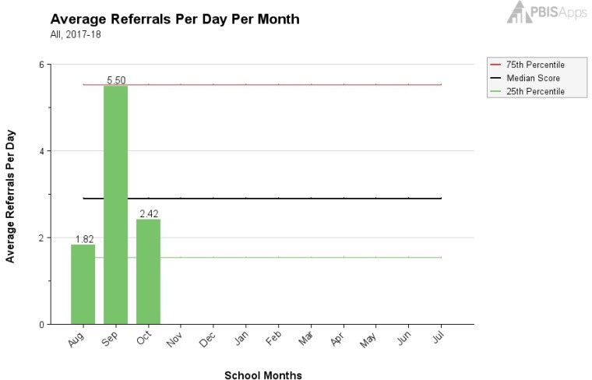
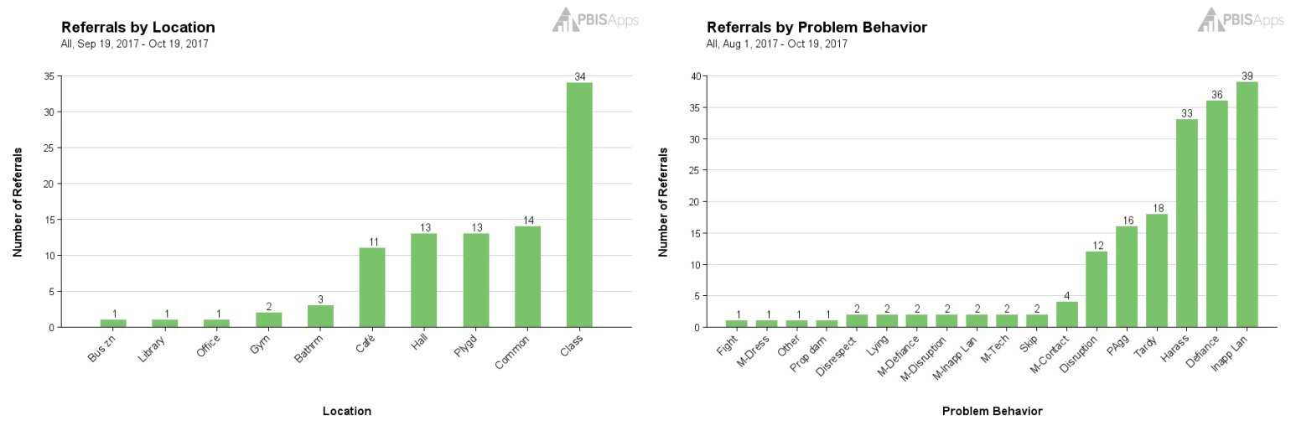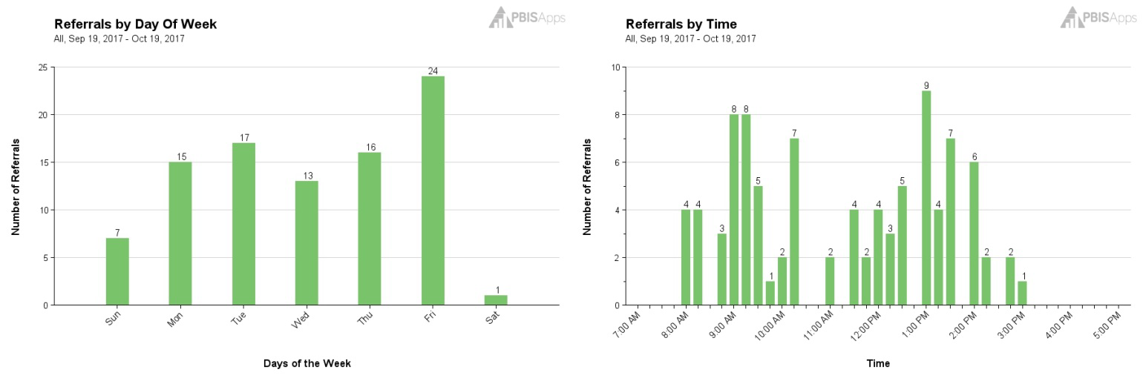

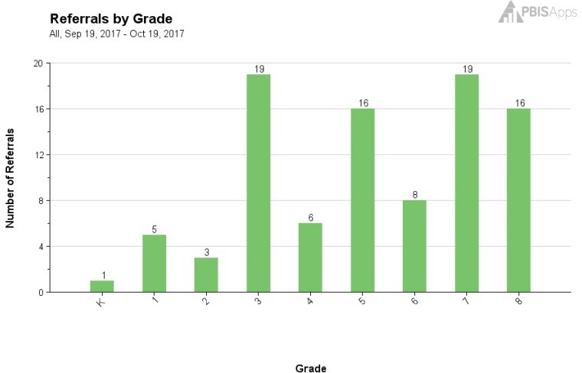
Summary (Who)
Grade: 3rd (20%), 7th (20%), 8th (17%), 5th
(17%)
Students 2-5 Referrals: 20 students since school started
Students 6+ Referrals: 6 students since school started
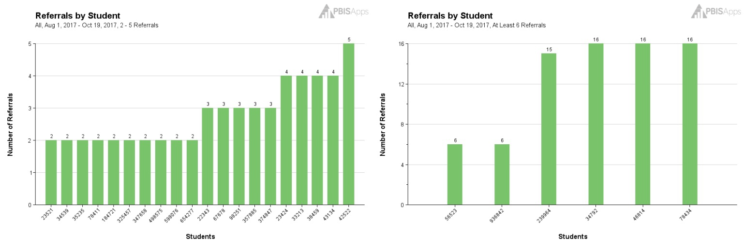

Update on Old/Previously Identified Problem: Grades 6-8 Defiance
Precise Statement: In September we identified that 12 students in grades 6-8 were referred (16 referrals) for defiance between August 22nd and September 18th (4 weeks = 4/week). Referrals were primarily in the classroom but also in common areas. There were not clear patterns by time of day and the behavior in this context seems to be maintained by avoiding tasks.
Update: In the last 4 weeks there have been 9 referrals (almost 50% reduction) in this context across 5 students (more than 50% reduction). Note of interest, the perceived motivation for the latest referrals show both task avoidance and obtaining peer attention.
Recommendation: Identify individual students and work directly with grade level teams or individual teachers.
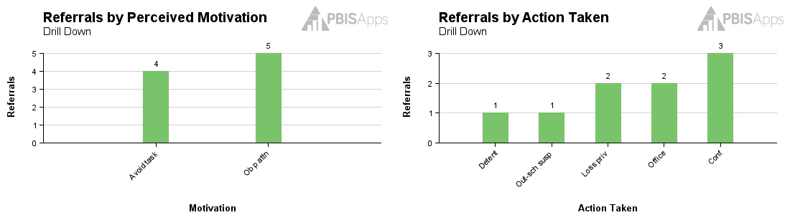
Potential New Problem: Hallway Tardiness across 6th Grade Latino Students

Since the beginning of the school year there have been 31 referrals submitted by 22 staff members for tardiness (mostly major) in the hallway, especially during lunch period (12:30pm – 1:30pm). All referrals were for Latino students (18 male and 13 female) in the 6th grade. Latino students are one of our subgroups vulnerable to disproportionality. The perceived motivation was almost exclusively reported as “Obtain peer attention”.
Notes/Recommendation: I expanded the date range from our typical 4 weeks once I noticed that this might be related to ethnicity/race. Given that this was a large group of staff and students I recommend including the district sub-committee on ethnic/racial disproportionality. They may have suggestions for solution development.
Additional Graphs of interest from SWIS Drill Down
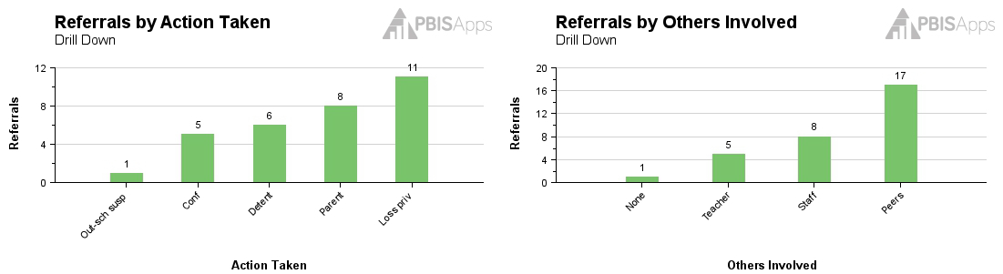

Wrapping Up
Swift at SWIS Evaluation
Because I want to use data-based decision making as your facilitator, please complete the evaluation below. If there is feedback that would be helpful beyond my role I may share your responses with my colleagues or staff at PBIS Applications. Please be respectful and constructive in your feedback as this will be more useful. If you would like to schedule a separate meeting to provide more detail please let me know.

For each statement below please identify (X or ) to indicate

Swift at SWIS materials and activities were useful in preparing myself and my colleagues for our SWIS user roles.

Not at all useful | Moderately useful | Extremely  Useful

Comments:

The Swift at SWIS training was delivered competently and with respect for learners.

Not at all useful | Moderately useful | Extremely  Useful

Comments:

SWIS will be useful for identifying student problem behavior patterns and improving the social climate at my school.

Disagree | Neutral | Definitely!

Comments:

The training environment (room, technology, participants) were conducive to focusing my attention on the features of SWIS. I would recommend a similar arrangement for your next Swift at SWIS training.

Try to avoid this | Fine (could be better or worse) | Keep doing it this way!

Comments:

I am comfortable contacting my facilitator for additional supports and understand that my facilitator will continue to support my school and keep in touch with me for as long as my school is using SWIS.

Uncomfortable | That’s fine | Great!

Comments:

(Optional) Name:
  - It’s okay to share my name and contact information if that would be helpful
  - I would prefer that you do not share my name or contact information when sharing my responses
  - Please check with me first before sharing my name or contact information when sharing my responses

Notes:

